1CB101 Week 3 Lab Part 2

1.

a)

for (int x=0; x<=25; x=x+5){

System.out.print(x + “ “)

b)

int x=2,y=5

while (x>-10);

if (x>0) {

System.out.print(x-y);

} else

System.out.print(x+y);

(y=y+2);

c) {

for (int x =10; x>0;x--){

if (x%4==0){

System.out.print(“”)

} else{

System.out.print(x + “ “);

}}}}

2.

a)

The value is 6

The value is 5

The value is 4

The value is 3

The value is 2

The value is 1

b)

The value is 0

The value is 1

The value is 2

The value is 3

The value is 4

The value is 5

The value is 6

The value is 7

The value is 8

The value is 9

c)

The value is 9

The value is 8

The value is 7

The value is 6

The value is 5

The value is 4

The value is 3

The value is 2

The value is 1

d) Nothing would happen

e)

The value is 5

3.

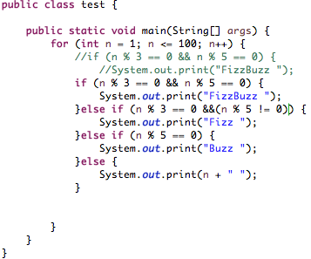

4.

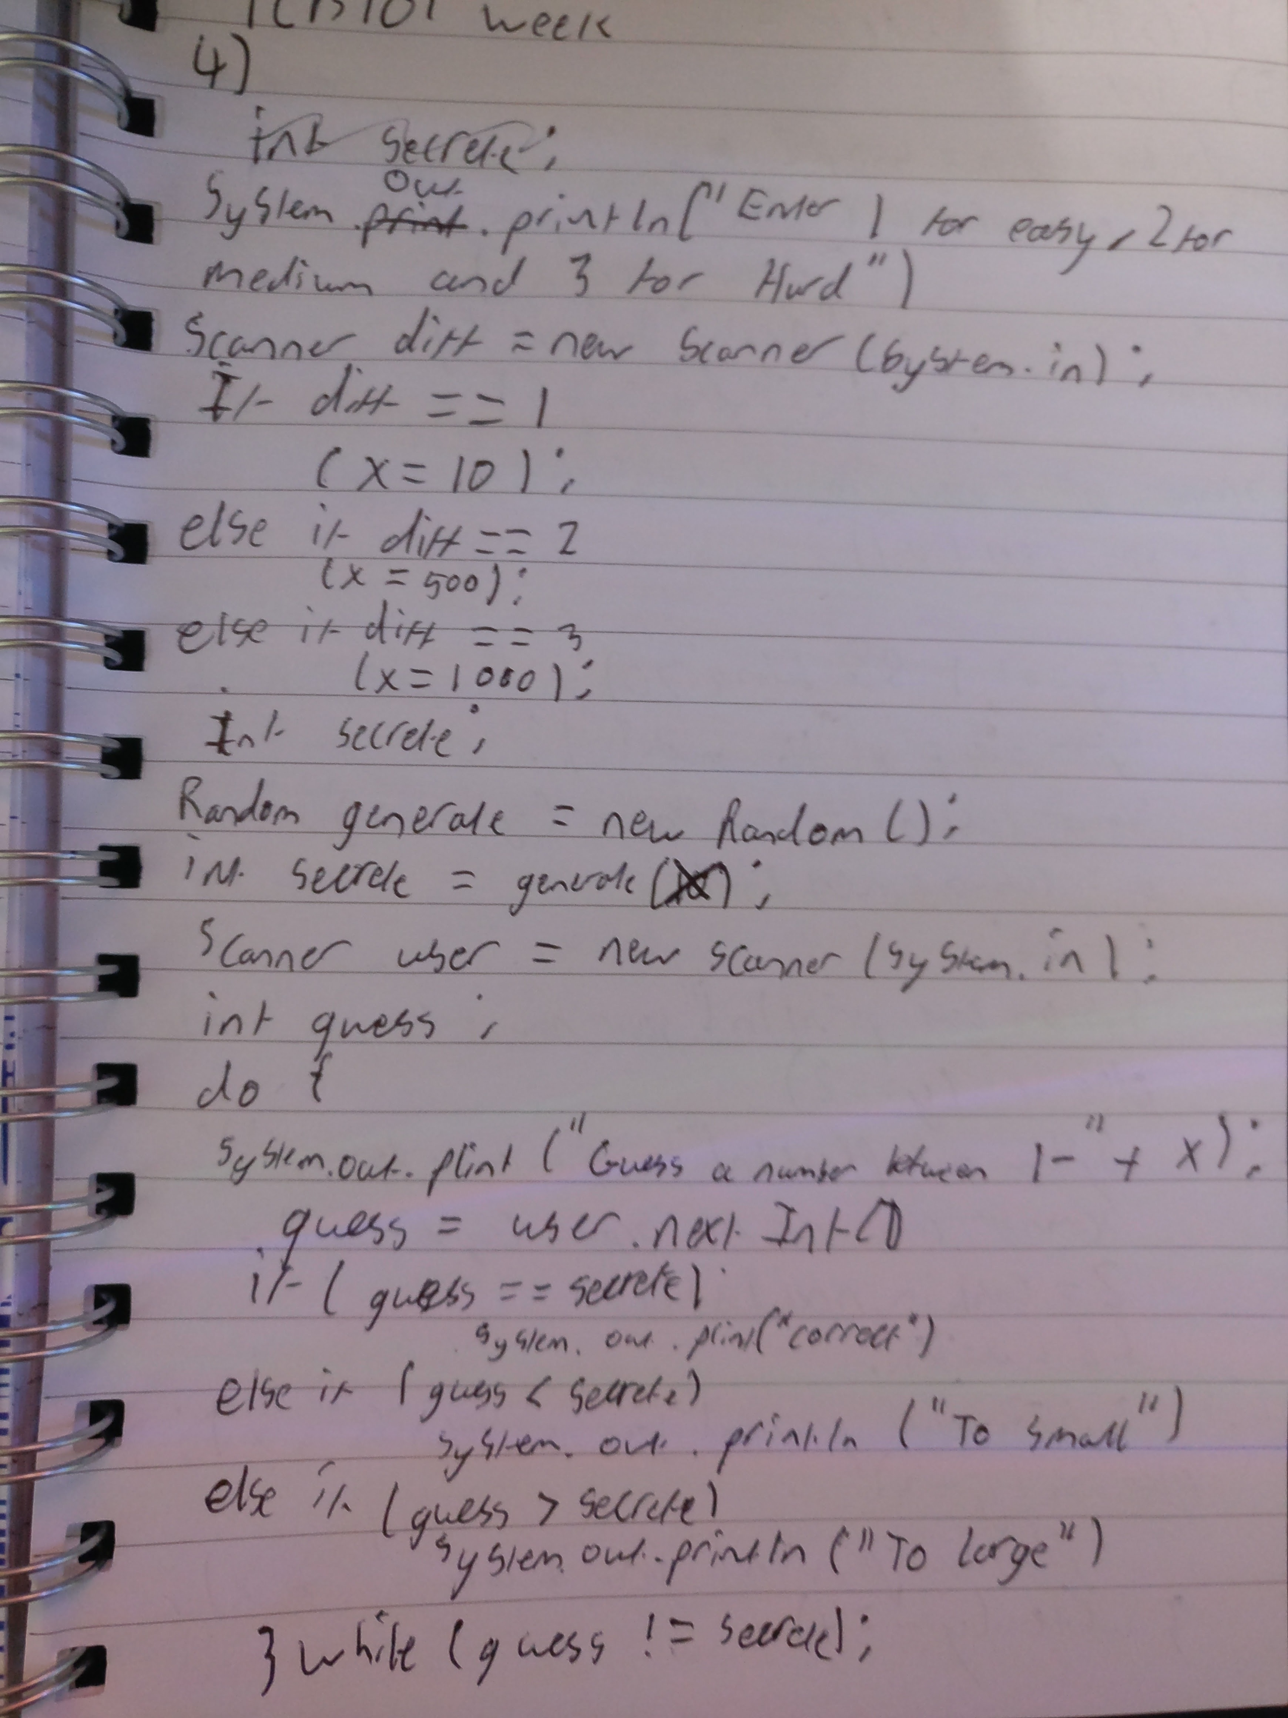

5.

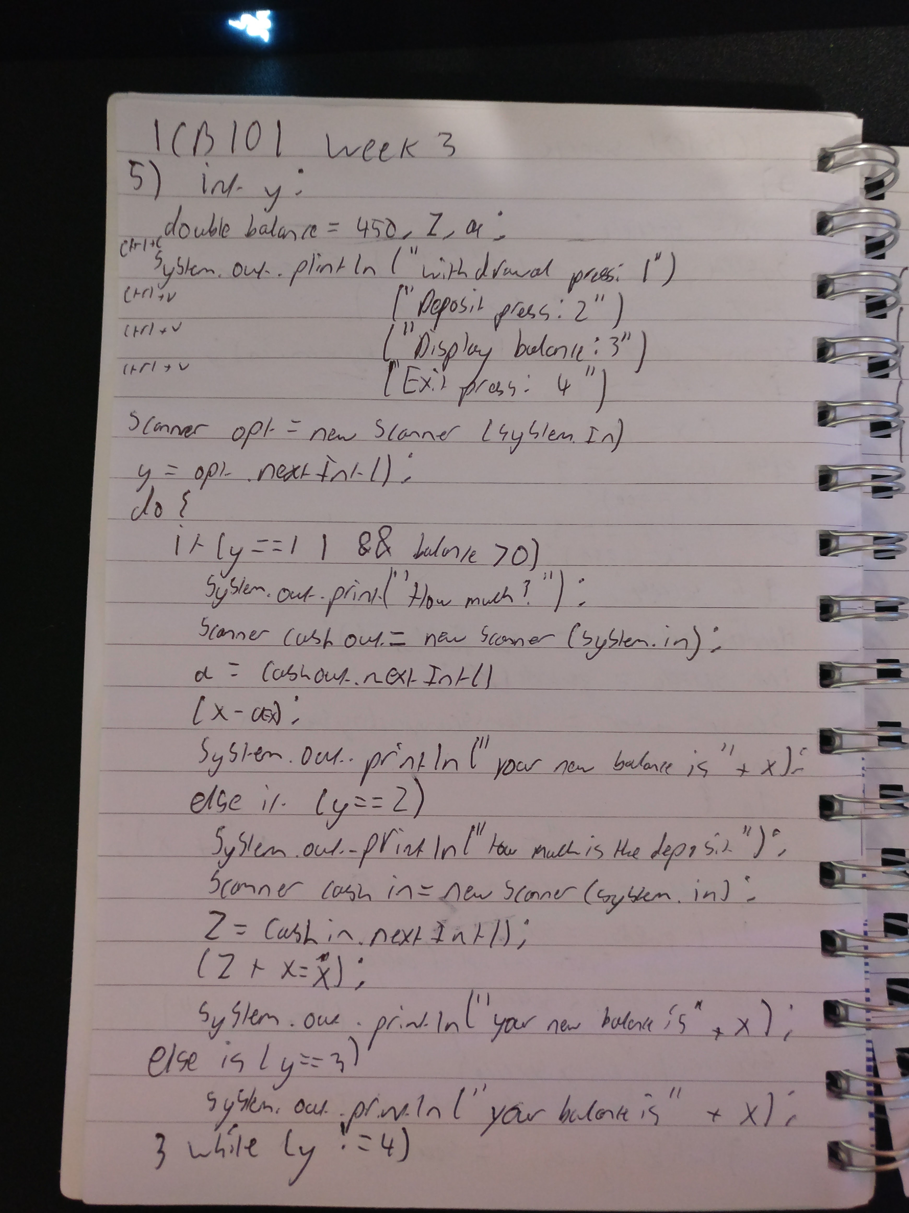

6.

